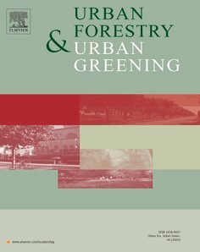
Urban Forestry & Urban Greening 62 (2021) 127165
Contents lists available at ScienceDirect

Urban Forestry & Urban Greening
journal homepage: www.elsevier.com/locate/ufug

Promoting wildflower biodiversity in dense and green cities: The important role of small vegetation patches
Kevin A. Vega a, b,*, Christoph Küffer a, b
a ETH Zürich, Institute of Integrative Biology, Universita¨tstrasse 16, Zürich, 8092, Switzerland
b Eastern Switzerland University of Applied Sciences, Institute for Landscape and Open Space, Rapperswil, CH-8640, Switzerland

A R T I C L E I N F O

Handling Editor: J Jun Yang

Keywords:
Ecological connectivity Green city design Nature conservation Species-area relationship Urban densification Urban biodiversity
Urban open space planning Wildflower
A B S T R A C T

The conservation and promotion of biodiversity in urban spaces has become a core concern in urban greening. As cities continue to densify, however, urban green spaces are becoming smaller and more isolated. Many hope that wildflowers, and with them also faunistic biodiversity, can be maintained through networks of small informal green spaces. Currently, there are little data available for city planners to answer the questions of how patch size
and ecological connectivity affect the population persistence of wildflowers in small vegetation patches. To address these concerns, we surveyed all vegetation patches greater than 1 m2 in public spaces across seven 1 km2 quadrats distributed across the city of Zurich, Switzerland. Our survey focused on a list of 166 herbaceous vascular plant species. We analyzed vegetation patch topologies (frequency distributions of size and connec-
tivity) and related it to alpha and beta species diversity. Dispersal traits of investigated species were used to interpret connectivity patterns. Over 75 % of patches were <20 m2 in size, however, these small patches made up only 3.4 % of total vegetation area. Species richness was significantly positively correlated with patch area.
Nevertheless, taken together, small patches had similar species richness and higher beta diversity than larger patches. These small patches contribute far more than expected to overall wildflower species richness in the city
– “punching above their weight”. This held true even for less common species. However, our research indicates that connecting these patches to one another and to larger green spaces is essential to unlocking their potential as habitats and potentially allowing for the natural colonization and reinforcement of existing populations. As cities densify, we must acknowledge that small vegetation patches such as tree discs or road margins are essential for the survival of wildflower populations and associated fauna, especially in highly urbanized areas.

Introduction
The 21st century has been called the “urban century”, with the challenge for conservationists to find new ways to conserve biodiversity in an increasingly urban world (Elmqvist et al., 2019; Kueffer, 2020; McDonald et al., 2018). Nevertheless, cities can be hotspots of biodi- versity including endemic and threatened species (Goddard et al., 2010; Ives et al., 2016; Lewis et al., 2019). Urban nature can be seen, felt, and enjoyed by a city’s population and, in doing so, help connect these people to nature (Kueffer, 2020; Miller, 2005). However, there is also densification of our cities (sometimes in combination with additional sprawl) as planners attempt to accommodate for a growing urban pop- ulation (Liu et al., 2020; Broitman and Koomen, 2015). This has placed an intense pressure on both existing urban green spaces and the ability of planners to allocate space for new ones (Geschke et al., 2018; Haaland
and van den Bosch, 2015; Lin et al., 2015). Thus, while properly managed urban habitats offer an opportunity to conserve biodiversity where people can experience it regularly, networks of urban green spaces are increasingly under pressure (Aronson et al., 2017; Colding et al., 2020; Fischer et al., 2018; Haaland and van den Bosch, 2015). In response to the growing concern of global biodiversity loss and recog- nition of ecosystem services, the political will now exists for cities to improve and expand their green infrastructure (Andersson et al., 2014; Aronson et al., 2017; Fischer et al., 2018; Lepczyk et al., 2017).
The diversity of different habitats in close proximity to one another is one factor that contributes to the relatively high biodiversity of cities (Zhou et al., 2018). Cities are habitat mosaics and urban green spaces can take many forms: such as woodlands, wastelands and ruderal sites, lawns, ornamental plantings, and meadows. Thus, biodiversity is not homogeneously distributed across cities, and there are often gradients of

* Corresponding author at: ETH Zürich, Institute of Integrative Biology, Universita¨tstrasse 16, Zürich, 8092, Switzerland.
E-mail address: kevin.vega@env.ethz.ch (K.A. Vega).
https://doi.org/10.1016/j.ufug.2021.127165
Received 19 January 2021; Received in revised form 20 April 2021; Accepted 23 April 2021
Available online 28 April 2021
1618-8667/© 2021 The Author(s). Published by Elsevier GmbH. This is an open access article under the CC BY-NC-ND license
(http://creativecommons.org/licenses/by-nc-nd/4.0/).

decreasing native specialists and increasing non-native species and synanthropic generalists from the city margins to the urban core areas – the so-called rural-urban gradient (Knapp et al., 2012; Malkinson et al., 2018).
In the densely built city centers, street trees and small patches of herbaceous vegetation are often the main remaining form of urban green (Colding et al., 2020; Jansson, 2014; Zhou et al., 2018). Such widely interspersed small urban vegetation can have important value as a habitat for arthropods, pollinators, birds, and rare plant species (Braaker et al., 2014; Ives et al., 2016; Robinson and Lundholm, 2012; Wenzel et al., 2019) and provides ecosystem services appreciated by urban residents (Fischer et al., 2013, 2018; Fischer and Kowarik, 2020). Small green spaces can help to mitigate deleterious effects of urbanization on biodiversity such as habitat loss and fragmentation, decreased popula- tion size, loss of genetic diversity (Lundberg, 2018; Miles et al., 2019; Van Rossum and Triest, 2012) reducing the risks of local extinctions (Duncan et al., 2011). Due simply to their quantity, these small green patches are the most encountered green spaces in cities by locals – especially in poorer neighborhoods that are often of lower ecological value (McPhearson et al., 2013; Peschardt et al., 2012).
The biodiversity value of patches of herbaceous urban vegetation
depends on a range of factors such as their size and connectivity (Liu et al., 2019; Beninde et al., 2015), management and land use history (Lerman et al., 2018; O’Sullivan et al., 2017), and the socioeconomics of their neighborhood (Hope et al., 2003; Leong et al., 2018). There is a growing research interest in understanding the interplay of these factors and uncovering the mechanisms which determine urban plant diversity patterns along urban gradients and in heterogeneous urban landscapes (Bretzel et al., 2016; Fratarcangeli et al., 2019; Malkinson et al., 2018; McDonnell and Hahs, 2013). However, most analyses focus on coarse-resolution landscape level patterns or relatively large urban green spaces (Hope et al., 2003; Hoyle et al., 2018; Kühn et al., 2004; Pysek, 1998). Parks, forests, post-industrial wastelands, and other large urban green spaces are by far the most studied form of city ecosystems (Beninde et al., 2015; Bonthoux et al., 2014; Lepczyk et al., 2017; Nielsen et al., 2014). While large diverse green spaces are undoubtedly a major component of a successful urban conservation strategy given the importance of habitat size for species richness (Beninde et al., 2015; Lepczyk et al., 2017; Matthies et al., 2017; Nielsen et al., 2014), only more recently have there been studies which have highlighted the po- tential contributions of smaller green spaces toward species diversity and the ecology and evolutionary processes characterizing wildflower
population dynamics in such highly fragmented urban environments
(Atkins, 2018; Duncan et al., 2011; Goddard et al., 2010; Omar et al., 2018). Evolutionary studies have shown, for instance, how urban habitat fragmentation may result in the rapid adaptation of plant pop- ulations in small urban fragments – for example reduced seed dispersal capabilities in the herb Crepis sancta (Andrieu et al., 2009; Cheptou et al., 2008; Dubois and Cheptou, 2017).
Thus, although the majority of urban ecology studies have focused on relatively large green spaces, the need to understand the ecology of small urban green spaces is only increasing in importance. As cities both grow in population and rapidly densify, they are left with ever fewer, smaller, and younger green spaces (Haaland and van den Bosch, 2015; Lin et al., 2015; Zhou et al., 2018). To counteract such loss, small urban green spaces are starting to be more widely promoted through green roof and facade creation, and the sowing of wildflowers along roadsides, in tree discs, on tramways, and in other urban fragments (Andersson et al., 2014; Childers et al., 2019). Unfortunately, some of these promotions fail. For instance, plant mortality can be high in small green spaces requiring expensive replanting (Roman et al., 2014; Smith et al., 2019; Widney et al., 2016). Thus, understanding the dynamics of small wild- flower patches in the urban matrix is fundamental for achieving bio- diverse dense cities.
Our study aimed at understanding plant diversity patterns in the
dense urban matrix at a very high spatial resolution. We surveyed
vascular plant species distribution in every patch of vegetation larger than 1 m2 in public spaces within seven 1 km quadrats across the entire city of Zurich. Zurich’s varied urban land use history and well docu-
mented flora (Landolt, 2001) make it an ideal city for such an approach. We addressed the following research questions: 1) how is ecologically-relevant public green space distributed across the city of Zurich; 2) what is the effect of green patch size and connectivity on wildflower alpha and beta diversity (per patch and across the urban landscape); and 3) what is the overall relative importance of large versus small patches for wildflower diversity in dense cities? In doing so we hoped to better understand the role of connectivity and patch size for shaping our urban floras to better manage and plan our cities’ green spaces.

Methods
  - Study site
Our study took place in the city of Zurich, Switzerland (47◦22′ N, 8◦33′ E) (Fig. 1). The municipality of Zurich covers an area of 92 km2, is
built between 400 and 600 m a.s.l., and has c. 430,000 inhabitants (Statistik Stadt Zurich, 2017). It is part of Zurich agglomeration area with c. 1.3 million inhabitants and an extent of c. 18,103 km2. Zurich has
a humid continental climate with warm summers and cool wet winters (January: 2 to 3 ◦C, July: 14–24 ◦C; mean annual precipitation: c. 1100 mm). The city is centered north-northwest of Lake Zurich and has forested hills flanking its western, eastern, and northern sides. This topography creates a multidirectional urban-rural gradient, with decreasing urbanization from the city center in almost any direction. Zurich contains c. 1000 herbaceous and terrestrial vascular plant species (excluding woody, water and exclusively planted species) of which c. 75
— +
% are native (incl. Archaeophytes) (Landolt, 2001). The native vascular plants of Zurich represent c. one third of all native vascular plants in Switzerland. Around 40 km2 of the municipality’s land are classified as
green space which includes large tracts of hillside forest, wooded cem- eteries, sports fields, gardens, and river-side greenspace (Grün Stadt Zurich, 2019). Zurich’s long history has seen it transform from its origins as a Celtic and then Roman settlement, through its walled medieval
period, its rise as a locally important industrial center in the 19th cen-
tury, and its current existence as a post-industrial, service-focused and international city.
  - Vegetation surveys
The study consisted of a vegetation survey focused on vascular plant species diversity conducted in seven 1 km2 squares across the city of Zurich based on a grid used by Landolt (2001) for a complete floristic
inventory of Zurich (Fig. 1). We selected quadrats that were at least 1 km away from one another and represented a diversity of urbanization levels, land use histories, and distances from the city’s center. All quadrats which met these criteria without significant overlap were included in our survey. Our quadrats included: high- and low-density residential areas, parts of the old medieval city, post-industrial re- developments, recently developed post-agricultural land, university campuses, train/tram lines, old-grown urban meadows, and public parks (Supplemental Table 1). The surveys took place over the summer months (May-September) of 2016 (three quadrats) and 2017 (four quadrats). Attempts were made to alternate work between different quadrats throughout the summer of each year to prevent phenology from affecting species identification in any one quadrat. The amount of sealed surface for each quadrat was measured using a vegetation map produced by Zurich municipality (Biotoptypenkartierung Stadt Zu¨rich, Grün Stadt Zurich, 2010–2014), we then took the inverse of this measure to calculate the percentage of the quadrat’s terrestrial area not occupied by sealed surfaces which we refer to as ‘proportion unsealed surface’ for each quadrat.

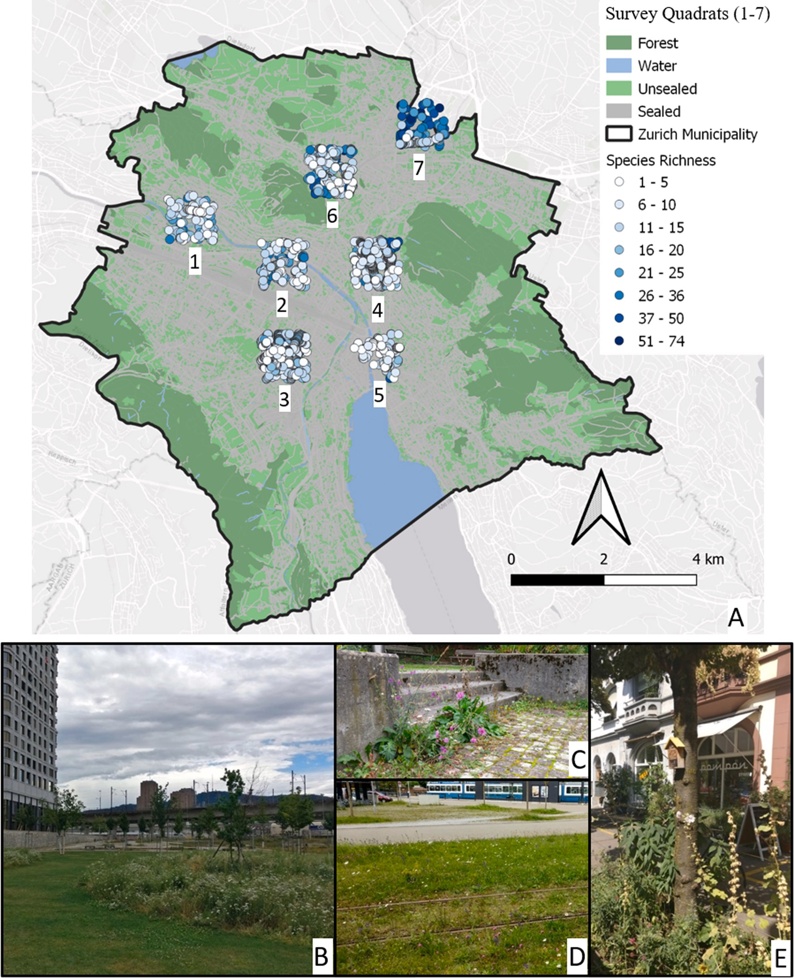
Fig. 1. A) Map of Zurich Vegetation Survey. Black outline: border of the municipality of the city of Zurich, dark green: forested land, light green: unsealed surfaces, grey: sealed surfaces, blue: rivers and lake. Each circle represents a vegetation patch that was surveyed. The color of the circle is indicative of the number of species identified. Examples of representative types of patches: Meadow (B), Ruderal (C), Green street (D), Tree disc (E).

Surveys consisted of walking through the selected quadrat and cataloging any “patch” of vegetation greater than 1 m2 accessible in
public space. Patches which were less than two meters apart from one another were combined into single patches. We recorded the patch’s centroid coordinates, length, width, and habitat type. Patch area was calculated by multiplying patch length and width. Patches were classi- fied as one of the following seven green space habitats, referred to hereafter as habitat types: 1) Tree discs (vegetated bases of street trees),
2) Green streets (wildflowers on streets and tram lines or their imme- diate verges), 3) Slopes (green areas, often along sloping terrain and relatively large in size, that are neither highly dynamic ruderal areas,
nor directly influenced by streets or well-defined meadow vegetation),
4) Ruderal areas (often disturbed areas such as wastelands), 5) Meadows (dense herbaceous vegetation including in parks and cemeteries), 6) Gardens (cultivated public greens space which still allow spontaneous
vegetation to grow), and 7) Green roofs (see Fig. 1). Patches were also classified into one of the following size categories: Small (<20 m2), Medium (20 300 m2), and Large (>300 m2). These thresholds were chosen based on size discontinuities associated with habitat types
—
observed (Small: mostly tree discs or roadside green spaces; Medium: slopes, gardens, or small meadows; Large: extensive and often older meadows, vacant lots, parks, cemeteries, and continuous green streets).

Highly maintained green spaces and completely cultivated gardens with no or very little opportunity for spontaneous vegetation to grown were not included (i.e. considered urban matrix). Vegetation patches that were heavily mown were only included in the survey if at least some individuals potentially flowered; very frequently mown turf lawns were excluded because they were assumed not to contribute significantly to wildflower population dynamics and connectivity.
We recorded species presence and absence in each patch. In 2016, we developed a list of 120 focal non-woody species which we believed to be of both high ecological and management interest. We then searched each patch intensively for these species but recorded all native and non- native vascular species excluding ornamental ones. In 2017 we focused the survey on a final list of 166 species to increase survey efficiency by adding to our focal list any new species which occurred in more than 4% of the 482 patches sampled in 2016 (Supplemental Table 3). All analyses
measure was based on the previously mentioned vegetation map pro- duced by Zurich municipality. Using this map we then calculated pro- portion of green space (i.e. all area except sealed surfaces and water) in a
200 m radius around each patch using QGIS version 3.12.3 (QGIS Development Team, 2020) (i. Proportion of Green Space). For this anal- ysis, data for quadrat 7 was only available for a portion situated on the land of Zurich municipality and thus data from this quadrat was excluded for any analysis of Proportion of Green Space (Fig. 1). The other two connectivity measures (ii. Estimated S_{i} and iii. Maximum S_{i}) were based on our survey data. We used the following negative expo- nential function developed by Moilanen and Nieminen (2002) to char- acterize seed dispersal kernels for the calculation of the connectivity value for a focal patch (S_{i}) from a distance-dependent weighted sum of all recorded patch areas (Aj) in a radius up to 200 m from the focal patch.
A_{j} (1)

were done with this list of 166 species. To avoid confounding effects, we
S_{i} =
exp
— Avg Dispersal Distance(dij — (ri + rj ))
excluded a few species that are frequently found in lawns (treated as matrix not available for reproductive plant growth according to our
∑ ( 1 )

methodology, Bellis perennis, Cardamine pratensis, Poa annua, Plantago
major, Taraxacum officinale) or frequently planted (Fragaria sp., Hedera helix).
  - Analysis
All analyses were performed in R version 4.0 (R Core Team, 2020). All graphs were produced either with the package listed in the specific analysis section or ggplot2 (Wickham, 2016).
    - Alpha diversity
Species richness was calculated for each patch. Species accumulation curves and rank abundance graphs were created using the vegan pack- age (Oksanen et al., 2013). Differences in species richness between different quadrats were compared using linear models with quadrat and species richness treated as fixed effects using the lme4 package (Bates et al., 2014) and pairwise Tukey post-hoc tests from the multcomp package (Hothorn et al., 2007).
We determined that there was significant spatial autocorrelation of the species richness of our patches by spline correlogram (point resample of 100) of species richness and the patch’s GPS coordinates with the package ncf (Bjornstad, 2004). In order to account for this, a linear mixed effect model (LMM) was constructed which included different spatial parameters. We identified both the nearest street and street section for each patch. We then built a LMM of species richness with street section nested within street and street within quadrat as nested random effects and patch size treated as the fixed effect using the lme4 package (Pinheiro et al., 2019). The addition of the spatially explicit random effects was confirmed to remove the spatial autocorre- lation of the residuals. Significance values were obtained from a Type III ANOVA of the model using the lmer.test package (Kuznetsova et al.,
2017). The slopes were obtained from the coefficients of the fixed effect estimates. The r2 (manually corrected with Fischer’s z-transformation)
was taken as the goodness of fit of the model using the r.squaredGLMM function from the Mumin package (Barton´, 2019). Standardized beta coefficients (which we use in conjunction with the variable’s slope and p-value to compare effect sizes between fixed effects) were calculated with an adaptation of the lm.beta function of the R-package lm.beta (Behrendt, 2014). This model was then repeated with the size categories in place of patch size as fixed effects in order to compare their effect on species richness.
    - Connectivity measures
We calculated three distinct but related measures of connectivity between patches in order to estimate its effect on species diversity. All three measures utilized a 200 m radius around each patch due to the results of our original analysis of spatial autocorrelation which showed a significant positive correlation up to 200 m. The first connectivity
The physical distance (d_{ij}) between patches was calculated using the
Distance Matrix function of QGIS for all patches that were 200 m or less away from a focal patch. As these distances are measured from the centers of the patches, we subtracted the sum of the radii of the two patches (r). We ran Eq. 1 with an average dispersal distances (Avg Dispersal Distance) of either 21 m or 113 m to produce ii. Estimated S_{i} and
iii. Maximum S_{i}, respectively. For ii. Estimated S_{i} we used the average dispersal distance of all our 166 focal species calculated using the dispeRsal package (Tamme et al., 2014) from the terminal velocity, dispersal syndrome, and seed mass data obtained from the Supplemen- tary Material of Hintze et al. (2013) (Avg Dispersal Distance =21 m). For
iii. Maximum S_{i} we used the average of the maximum dispersal distances (which were significantly larger than those calculated for ii. Estimated S_{i}) for of all focal species based on the model dataset included in the dispeRsal package (Avg Dispersal Distance =113 m).
    - Species area relationship & connectivity
The positive relationship between a habitat’s area and it’s species richness (species area relationship, SAR) has long been considered as close to an ecological general rule as can exist (Lomolino, 2000). Using a simple linear model, we estimated the effect of patch size on species richness. We also examined the correlation of each connectivity measure with one another using simple linear models and, as expected, the connectivity measures were found to significantly correlate with one
another (p < 0.001). The model was then expanded by incorporating our
three measures of connectivity. Simple linear models were fitted to determine the effects of each measure on species richness alone. As there was a significant level of correlation between the two S_{i} values, we chose to test each of them separately in our mixed-effect model. LMMs were fitted for species richness, with patch size, proportion green space, and one of the S_{i} connectivity measures and their interaction treated as fixed effects and street section nested within street nested within quadrat treated as nested random effects. Due to the prevalence of both very small and very large sizes and connectivity measures we log transformed species richness, patch size, and connectivity. All model evaluation was based on AIC_{c} and compared using the dredge function.
    - Beta diversity
In order to compare the contribution of smaller patches versus larger patches to total surveyed species richness we calculated the “Sloss- index” (Quinn and Harrison, 1988). This index compares species accu- mulation curves over the cumulative sampling area by incrementally adding either the smallest or largest patches first. The ratio of the in- tegrals of the two curves is then compared producing the Sloss-index which either indicates that the larger patches support more unique
species per area sampled (<1) or smaller patches support more (>1).
This calculation and the subsequent graph were made using the sloss

package and scripts (Vargas et al., 2013). These measures were then repeated for a subset of only the 30 most common or uncommon species in order to identify the robustness of the general pattern (Roden et al., 2018).
We used the beta.sample function of the betapart package to calcu- late beta diversity (Baselga and Orme, 2012). We calculated the Jac- card’s dissimilarity index (β_{jac}) and its two components – species turnover (β_{jtu}) and nestedness (β_{jne}) – for samples of 20 patches, resampled 1000-times. Jaccard’s dissimilarity index was chosen over Sorenson’s due to its reportedly higher accuracy when species sampling is incomplete (Roden et al., 2018). Beta diversity measures were compared between the patches of different quadrats and among the three size classes at both the overall and within-quadrat level using a linear mixed effect model. This analysis was also performed with a subset of the data containing only the 30 most and least common species.
In order to incorporate spatial autocorrelation into our analysis of
beta diversity we compared beta diversity between smaller and larger patches with sliding window based beta diversity comparisons using the package CommEcol (Melo, 2013). For this, we ordered all patches from smallest to largest and calculated pairwise Jaccard dissimilarities be- tween all patches within a “window” or subsection of 15 patches beginning with the smallest window and continuing with the next larger window of 15 until all patches were measured, for a total of 142 win- dows. We then fitted a linear model to mean window pairwise Jaccard dissimilarity with mean window patch size as a fixed effect and mean geographic distance between patches within a window as a random ef- fect to account for spatial autocorrelation. This allowed us to compare the average Jaccard dissimilarity of windows of 15 patches continuously across the patch size gradient.

Results
  - Green space
We surveyed 197,738 m2 of public green space divided into 2130 individual patches across seven 1 km2 quadrats (Table 1). Patch sizes
ranged from our minimum area of 1 m2 to nearly 30,000 m2. These green
spaces were not evenly distributed among the seven quadrats with the number of patches (144–630), total patch area (5117 46,968 m2) and median patch size (3.4 30 m2) varying greatly from quadrat to quadrat.
—
—
The central old city quadrat 5 had 139 patches (the second fewest of any quadrat), the lowest amount of total patch area (5117 m2, average: 36.8 m2, median: 6.25 m2), and the lowest proportion of green space (12.8
%). The low-density urban-peripheral quadrat 1 had even fewer patches (134), however, due to the presence of large vineyards, parks, and meadows, it had the second highest total patch area (25,252 m2,
average: 452 m2, median: 30 m2) and the highest proportion of green
space at the quadrat-level (55.5 %, calculated with the aforementioned vegetation map of Zurich municipality). The quadrat with the highest amount of total patch area was surprisingly the recently developed high-

Table 1
density commercial quadrat 7, which had many small but also several very large patches (206 patches, 46,968 m2, average: 259 m2, median:
27.5 m2). However, unlike the older meadows of quadrat 1, almost all of
these patches were recently established green streets or building- adjacent sown flower meadows resulting in the quadrat having high connectivity. In general, we found that the urban core had very little green space compared to the periphery, however, some core quadrats had extensive green streets and infrastructure resulting in high con- nectivity between the patches (i.e. high median Estimated S_{i}) as compared to some peripheral quadrats with large sections of lawn (Table 1).
Most public green patches in the city of Zurich were small and pre- dominantly consisted of street tree discs (71 % of all patches) (Fig. 2 &
Supplemental Fig. 1). Thus, in all seven quadrats patches were on average small (median: 3.75 m2, average: 92.8 m2) with over 75 % of all patches <20 m2 which accounted together for only 3.4 % of the total green area surveyed. Most green space area (82 %) was contributed by just the top 5% largest patches (those >300 m2 in size).

  - Overall species richness
The final species list used in the survey consisted of 166 species covering 122 genera and 35 families (Supplemental Table 3). The spe- cies on the list were mostly native species (including Archaeophytes, 141), while 25 were not native to Switzerland. The frequency of species occurrence differed greatly in the survey (Fig. 3 & Supplemental Table 2). There were also clear differences in the species occurrence frequencies between the patch size categories. While Plantago lanceolata occurred frequently in patches of all sizes, field herbs such as Trifolium pratense occurred often in Large and Medium patches whereas more shade tolerant ruderal species such as Geum urbanum and Polygonum aviculare were very common in small tree discs (although Small patches overall had flatter rank abundance curve suggesting a more equitable abundance of species) (Fig. 3; Supplemental Table 2).
Plant species richness was not equally distributed throughout the city
with individual patches having between 1–41 species (Table 1 & Sup- plemental Fig. 2). Quadrats had very different median species richness, ranging from eight species per patch in the central old city quadrat 5–23 species per plot in the recently developed commercial quadrat 7. In general, the core densely urbanized quadrats (3 & 5) had low median patch level species richness while the peripheral quadrats with many large green patches (1 & 6) had higher median diversity. However, in- vestment in biodiversity support also played a major role. Highly ur- banized quadrats containing extensive green infrastructure (2 & 7) had high median diversity yet the relatively peripheral and green (47.5 % unsealed surface) quadrat 4 had low median biodiversity outside of its single large park.

  - Alpha diversity and connectivity
Species richness was significantly positively correlated with patch

Summary of diversity and topology data for all quadrats in the vegetation survey: the number of patches in each quadrat; the mean and median sizes of those patches; the proportion of the quadrat’s total area that is not sealed surface; the median connectivity (Estimated S_{i}) of its patches; and the mean and median species richness of its patches.

Quadrat Number of Patches
Mean Size (m2) Median Size (m2) Proportion Green Space (%) Median Estimated S_{i} Mean Richness Median Richness

1 134 452.3 30.0 55.5 190.0 12.1 11
2 209 67.4 10.0 20.0 76.5 13.4 12
3 626 8.5 3.4 15.8 16.5 10.9 10
4 560 71.9 3.7 47.5 29.0 9.0 9
5 139 36.8 6.25 12.8 44.4 9.1 8
6 304 83.4 4.0 48.6 46.0 15.2 13
7 158 297.3 27.5 – 131.7 24.9 23
Total/Mean 2130 92.8 3.75 32.8 27.5 13.0 10

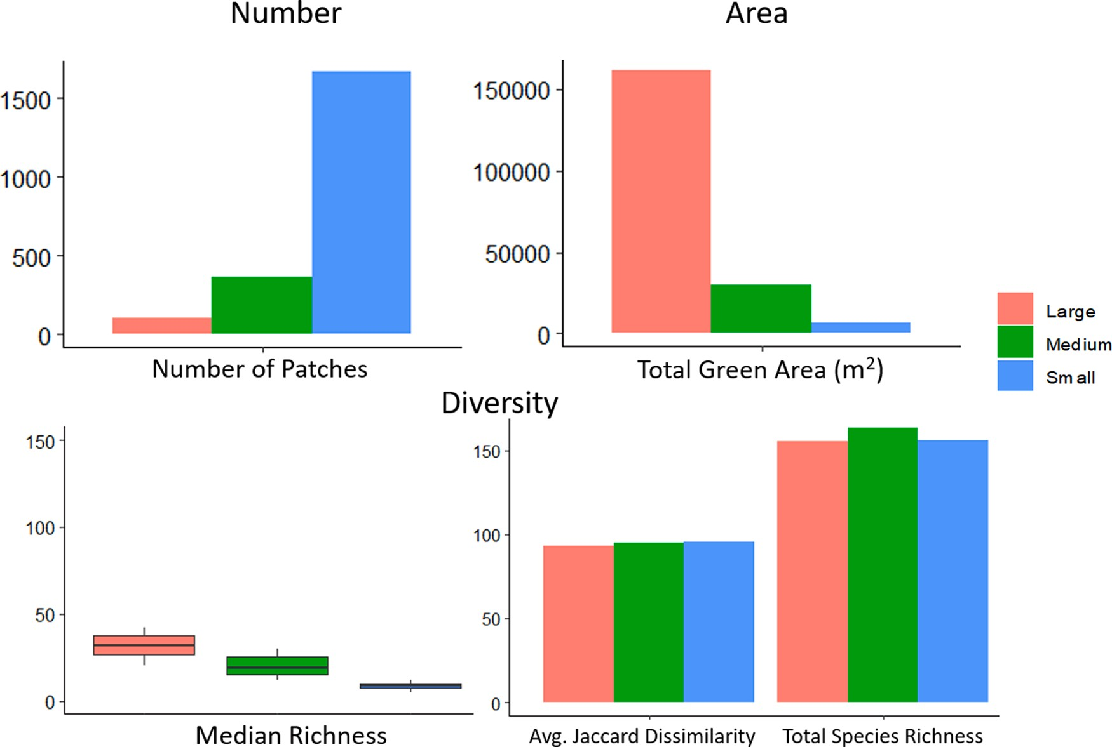
Fig. 2. Number of patches, total patch area, and different average measures of species richness for vegetation patches classified into three size classes: Large (>300 m2), Medium (300 - 20 m2), Small (<20 m2). The species richness measures are: median species number per patch (calculated across the seven quadrats), average Jaccard dissimilarity of groups of pairs of patches of the same size classes, and total number surveyed species found in a particular size class.

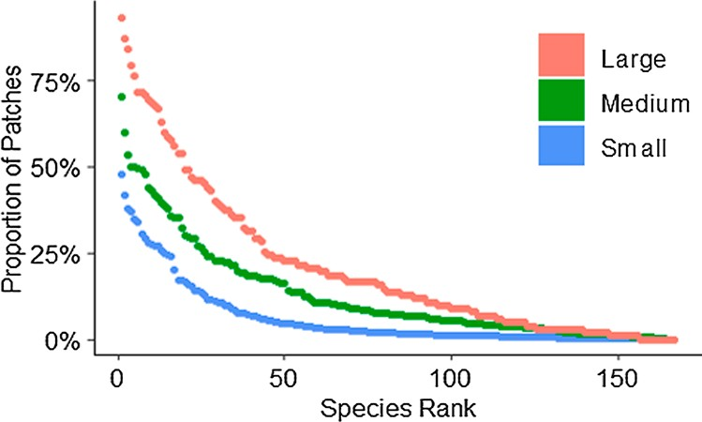
0.39, Size beta coefficient 0.84; Estimated S_{i} beta coefficient 0.19);
= =
however, the interaction variable appeared to be slightly negatively correlated with richness (p < 0.001, Interaction beta coefficient 0.29) (Supplemental Fig. 3). In order to better understand the effect of this interaction, we compared the effect of the Estimated S_{i} on species richness between the three size categories (Supplemental Fig. 3). While
=
Small and Medium sized patches had significant positive effect of Esti- mated S_{i} on species richness (p < 0.05), there was no significant cor- relation in Large patches. Further investigation revealed that the slope of the effect of Estimated S_{i} on species richness was twice as Large for Small
patches (0.06) than Medium patches (0.03). As this estimate also was the most clearly based on the biology of our study species, we used it as the

Fig. 3. Species rank abundance curves for the three size categories. Species are arranged by their abundance in the respective size class from left to right on the x-axis, and the proportion of patches in which a species is found in that size category is given on the y-axis.

size in the log transformed LMM confirming the applicability of the SAR framework (p < 0.001). This relationship was true both overall and within each of the quadrats, size categories, habitat types, except for roof tops (Supplemental Fig. 1). While the exact slopes and intercepts of each SAR linear regression were different, the consistency of the pattern
between all quadrats, sizes, and habitat types reinforced the general nature of this relationship. After dividing the patches into their size categories, we found that Large patches had higher average species richness (33 13 SD) than Medium patches (21 11) and both had higher average richness values than Small patches (9 4). These dif-
±
± ±
ferences were found to be significant in the LMM which included spatial random effects (p < 0.001).
After comparing the models including the different connectivity
measures using dredge, models only including Estimated S_{i} had the
lowest AIC, and Estimated S_{i} had the most significant effect on species richness. The chosen LMM revealed a positive significant relationship
basis for the remaining comparisons.

  - Beta diversity
The results of the Sloss-index analysis showed that despite individual larger patches having a higher average species richness, multiple smaller patches have more species per m2 sampled than multiple large ones
(Sloss-index 1.42, Fig. 4A). This effect is even stronger when focusing on the 30 rarest species (Sloss-index 2.64, Fig. 4B) whereas it reduces in importance with the 30 most common species (Sloss-index 1.18, Fig. 4C).
When beta diversity was compared between size classes, there was a non-significant difference between Small and Large patches, with Small patches having higher β_{jac} and β_{jtu} (no differences were found in β_{jne} or the values of Medium patches) (Fig. 5). This was also found to be the case when comparing only the 20 most common species. However, the sliding window based approach and subsequent linear model which included spatial distance (to account for spatial autocorrelation) indi- cated a strongly significant effect of size on beta diversity, with larger
patches being significantly more similar to one another than smaller
= =

between species richness and both size and connectivity (p < 0.001; r2 =
ones even at far geographic distances (adjusted r2 0.53, p < 0.001, β
-0.66) (Supplemental Fig. 4). While species richness generally differed

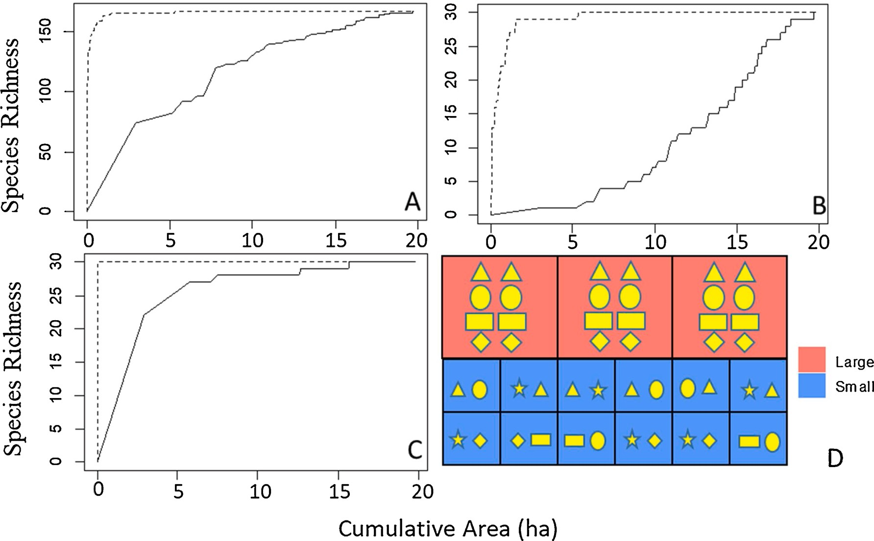
Fig. 4. Sloss-index analysis of beta diversity across small versus large patches. Dashed lines represent analyses that add smallest patches first and consecutively adding larger patches until all surveyed patches are added, whereas solid lines represent analyses that begin with the largest patch and consecutively adding smaller patches. A) All species included, Sloss-index = 1.42; B) Only the 30 least common species, Sloss-index = 2.64; C) Only the 30 most common species, Sloss-index =
1.18. D) Conceptual figure highlighting the higher total species diversity (shown by different yellow shapes) of Small patches vs Large patches of the same total area.

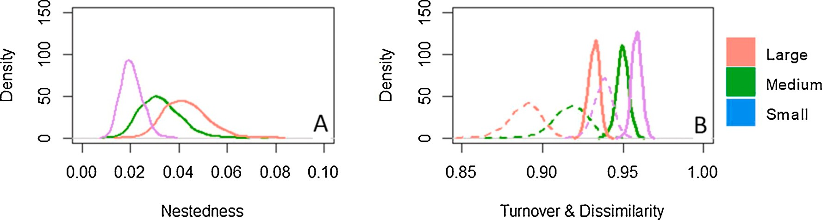
Fig. 5. Beta diversity of species for three size category of patches and a spatially explicit model of all patches. A) Distributions of the Jaccard’s Nestedness; B) Distribution of Jaccard’s Dissimilarity (solid lines) and Jaccard’s Turnover (dashed line).

significantly between quadrats, beta diversity appears to be more similar than alpha diversity. Betapart’s beta.sample analysis revealed no sig- nificant difference in the distribution of β_{jac},β_{jtu}, or β_{jne} between the seven quadrats.

Discussion
As cities continue to densify and grow, existing green spaces and the vegetation they support have come under increasing pressure, and urban biodiversity in general declines (Colding et al., 2020; Pyˇsek et al., 2004; Zhou et al., 2018). To combat such pressures, cities must understand how to help promote and maintain self-reproducing ‘wild’ floras in an intensively used urban matrix (Bonthoux et al., 2019; Kühn, 2006; Planchuelo et al., 2020). While formal green spaces are protected through planning legislation and policies, densification might in particular threaten informal green spaces (such as wastelands and reserve land for future buildings) and small vegetation fragments (Bonthoux et al., 2014; Richards and Belcher, 2019). We focused on such informal vegetation patches –especially small ones – and their role for
the ecological connectivity of herbaceous wildflowers. To our knowl- edge, we present the first spatially explicit high-resolution survey of spontaneous herbaceous vegetation that systematically searched all
public space in contrasting urban neighborhoods down to patches sizes of 1 m2.
We performed our study in Zurich, Switzerland, which is a typical example of a growing and densifying European city. The population of the city and surrounding agglomeration has exploded in the last 40 years from 700’000 to over 1.3 million and is projected to surpass 1.5 million by 2030 (United Nations, 2018). Within the municipality of Zurich, the population is expected to grow by 25 % by 2040 on the same land surface (Kommunaler Richtplan, 2019). While Zurich is situated in-between forested hills and a lake, the city center is already densely built up with only 10 % of the surface currently classified as ecologically valuable (Grün Stadt Zurich, 2019). At the same time, the municipality of Zurich is attempting to promote biodiversity through top-down ini- tiatives (e.g. Mehr Als Grün, 2019), like many other cities around the world (Schewenius et al., 2014). The overall aim of our study was to better understand whether this is possible for wildflowers through a

better planning and use of distributed, but often small, vegetation patches across a densely built urban landscape.
  - Plant diversity in vegetation patches across the urban matrix
While the urban herbaceous flora of Zurich is rich in species and phylogenetically and ecologically diverse, it is dominated by few com- mon and many rare species. We found around 150 relatively frequent herbaceous vascular plant species. These can arguably be interpreted as those that might currently maintain self-sustained viable populations in the urban matrix of the built-up areas of Zurich. Of these, about 50 species were common while the other 75 % occurred in 10 % or less of
the patches (Fig. 3, Supplemental Table 2). As a result of this skewed relative species abundance distribution, we only recorded between 116 and 151 species in the different 1 km2 (Supplemental Table 1), which
made up c. one third of all herbaceous vascular plants species recorded by Landolt (2001) in the same 1 km2 quadrats (423–461 species, Sup- plemental Table 1). While some of the additional species found by
Landolt (2001) are specialists of habitat types that we did not cover (wooded, wetlands, nature reserves, etc.) many may have occurred in our patches but were so rare and ephemeral that they would only be detected with a more comprehensive multi-year search as done by Landolt (2001).
Our focal 166 vascular plant species represented high phylogenetic diversity (122 genera from 35 families) and diverse ecological origins: ruderal (e.g. Geum urbanum or Sisymbrium officinale), meadows (e.g. Achillea millefolium, Centaurea jacea or Salvia pratensis), specialists of dry and/or rocky environments (e.g. Petrorhagia spp., Sedum spp.), or garden escapes (e.g. Oenothera biennis or Pastinaca sativa) among others. Many of the species, including the common ones, were actively sown for conservation by the city (e.g. Buphthalmum salicifolium, Centaurea cyanus or Echium vulgare) or by guerilla gardeners (e.g. Althea rosea) under- lining the high potential to actively promote spontaneous wildflower biodiversity in cities. Neophytes made up only 15 % of the survey (e.g. Erigeron annuus or Solidago canadensis). Many of the recorded species have high aesthetic appeal (e.g. Centaurea scabiosa or Leucanthemum vulgare) and are known to be of ecological value (such as for wild bees, e.
g. Buphthalmum salicifolium, Echium vulgare or Salvia pratensis, or but-
terflies, e.g. Lotus corniculatus) (Nichols et al., 2019). Indeed, urban wildflower patches with such species can provide both habitat and re- sources for a variety of wildlife (such as beetles and other invertebrates as well as insectivores such as house sparrows) (Norton et al., 2019; Weir, 2015). Additionally, several recorded species are protected or endangered in the canton of Zurich (e.g. Centaurium erythraea, Melica ciliata, Petrorhagia sp.). Landolt (2011) documented another 12 nation- ally endangered plant species in the habitat types we surveyed across the city. Planchuelo et al. (2020) analyzed the distribution of 213 endan- gered plant species in Berlin and found that c. two thirds occurred in built-up areas, vacant lots, rooftops, and similar (novel ecosystems in their terminology) and 20 % of the species occurred exclusively in this habitat class.
  - Topology of urban green spaces
Our study highlights the great heterogeneity of urban green spaces and the importance of including a wide range of urbanization levels and habitat types in an analysis of urban biodiversity (Threlfall et al., 2015).
The most striking variation was the huge variation in patch sizes in our survey (1 m2- 30,000 m2) (Fig. 2). Over 75 % of patches were Small green spaces as defined by our size categories (<20 m2), however, these accounted for less than 5% of the total green space surveyed. Small
patches were on average much closer together (average nearest neighbor small to small: 16 m) than either Medium (55 m) or Large patches (106 m), and they made up a higher proportion of surveyed green space in the highly urbanized quadrats than in the more periph- eral ones. Small and clustered green spaces were especially common in
the quadrats which have seen extensive green infrastructure additions such as green tram lines and road verges (2 & 7) and were lacking in the dense old city (5) indicating the high potential to promote small patches
in a dense urban matrix. On the other hand, the largest patches (those >
300 m2) were rare (5% of all patches) but made up 75 % of all green
space in the survey. Large patches were most often either remnant pe- ripheral green spaces – e.g. former agricultural meadows or vineyards, abandoned post-industrial ruderal sites, or purposefully planned public parks set aside for recreational use.
  - Relative importance of small versus large patches
As expected from species-area relationships (Beninde et al., 2015), patch-level alpha diversity increased with patch size: Large patches had about three-times more species than Small ones. But even Small patches occasionally had high species numbers of up to 30 species in a single patch. Additionally, we found almost all of the surveyed species (154) in Small patches despite their small individual and combined total areas (Fig. 2). The strongest contribution of Small patches to species diversity, however, becomes visible through the different analyses of beta-diversity (Figs. 4 and 5). Two Small patches are more dissimilar
than two Large patches, and multiple Small patches have a higher spe- cies diversity per m2 than multiple Large ones (Sloss-index, Fig. 5D). While c. 2 ha (20’000 m2) of Small patches suffice to sample 150 species,
10-times more area is needed to reach the same total species number with Large patches (Fig. 4A), and this pattern holds even for less com- mon species (Fig. 4B). This visual result of this can be seen in Fig. 6. These results are in line with the comprehensive literature review by Fahrig (2020) that showed that several small habitat islands consistently outperform single large ones in terms of species richness, even in matrix landscapes that are extremely hostile as in the case of cities.
A biological explanation of our results may be that small patches have very dynamic plant communities characterized by high turnover (i.
e. immigration and local extinction) and sample a relatively random subset of the local species pool, while large patches – such as long- established meadows – have the same stable plant community in all locations with populations that rarely die out and a competitive envi- ronment that hinders colonization of new species. Indeed, in a re-survey of the larger remnant meadow patches in Zurich after more than 20 years, we found very little compositional change (Vega et al. unpub- lished data; Wilhelm, 1997). Large meadows might be more capable of maintaining self-sufficient populations of plants and pollinators (although see Muratet et al., 2007 for a counter example), while small urban green spaces likely rely on frequent immigration from other patches (Beninde et al., 2015; Goddard et al., 2010; Planchuelo et al., 2020). Therefore, connectivity has significantly less of an effect on species richness as a patch’s size increases in the LMM, and only species numbers of patches of the Small and Medium size categories were significantly influenced by connectivity (Supplemental Fig. 3). Our study is not the first to identify the importance of connectivity for the biodiversity of small green spaces. Omar et al. (2019) conducted a study of the colonization and extinction of 15 species in tree discs in the city of Paris over several years and found evidence that larger green spaces may act as sources for populations in tree discs. In summary, while small
urban vegetation patches such as tree discs are often identified as useful
connectors of other green spaces, their value as diverse habitats in and of themselves may be under estimated (Atkins, 2018; Bonthoux et al., 2019; Omar et al., 2018, 2019).
  - Implications for practice
The conservation value of spontaneous vegetation in highly urban- ized “novel” habitats is increasingly recognized (Bonthoux et al., 2019; Robinson and Lundholm, 2012), especially in spacious ruderal sites – Planchuelo et al. (2020), for instance, documented a positive correlation between patch size and occurrence of endangered species. In densifying

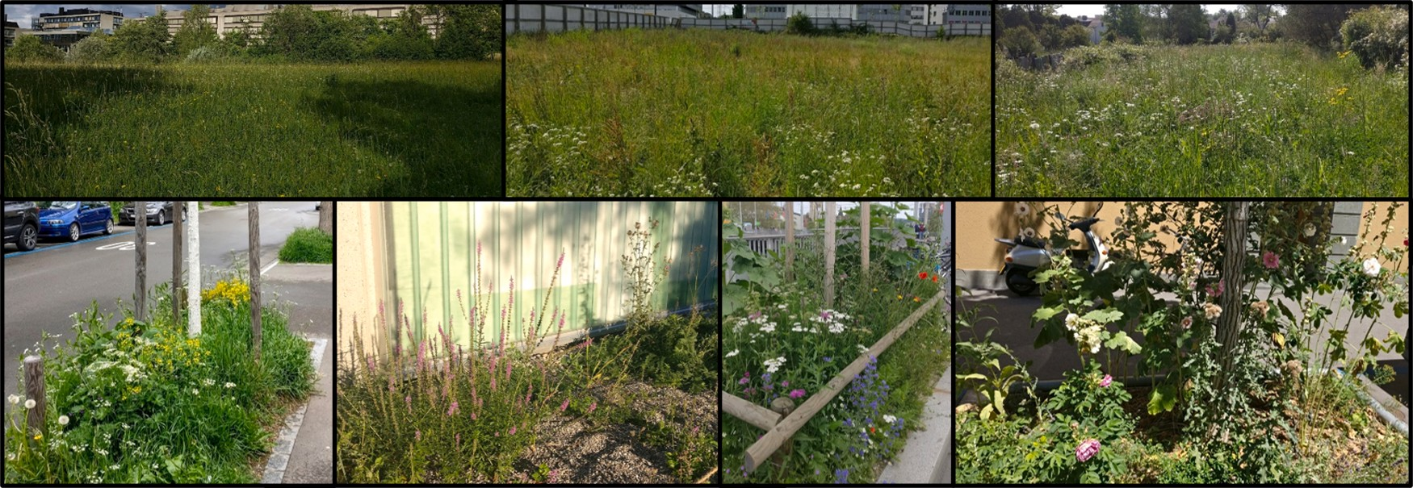
Fig. 6. Visual summary comparison of Small and Large patches. Photo examples of the visual differences in diversity of species found in Large (top) and Small (bottom) patches. Large patches tended to have high individual species richness (alpha diversity) while being more similar to one another (beta diversity) with several dominant species, whereas Small patches had low individual alpha diversities but higher beta diversity overall with a more equal proportion of species.

cities such as Zurich, large urban wilderness areas are becoming increasingly rare, and we must therefore better understand how wild- flower diversity can be promoted across the urban matrix even in small vegetation patches. Such vegetation patches in densely populated and built-up areas will bring biodiversity to the places where the majority of the city’s population reside, thereby expanding those who benefit from the potential ecosystem services of these green spaces such as: air filtration, temperature reduction, storm water management, aesthetics, and health improvement (Jansson, 2014; Phillips et al., 2020; Sa¨umel et al., 2016). This is especially true for residents of lower socioeconomic status which generally have reduced access to larger green and bio- diverse spaces (Hope et al., 2003; Leong et al., 2018; McPhearson et al., 2013).
Our study indicates that even small vegetation patches can signifi- cantly contribute to the maintenance of a rich wildflower flora in cities if
they are frequent and close enough together (Table 2). Omar et al. (2018) suggested that tree discs should be at least 4 m2 in area to reduce

Table 2
Summary of results and recommendations for practice.
Category Result Recommendation

the crowding effect of the tree and should be close enough to large spaces to allow for the colonization of species (100 400 m). Our results
support these values with only patches greater than 4 m2 consistently having >10 species per patch. We estimated our species average dispersal distances to be between c. 20 and 110 m, and our evaluation of
—
the spatial autocorrelation of species richness suggest a distance of 200 m to be the maximum range within which patches significantly influ- ence one another – a value further supported by the results of Muratet et al. (2007). Thus, our data indicates that dense networks of small to medium sized patches are needed. This can be achieved by ensuring that areas that are today often sealed, characterized by compacted soil, or regularly weeded (including with herbicides), are instead maintained in a state that allows for spontaneous vegetation to grow (e.g. tree discs, tramways, parking lots, sidewalks, etc.). In Swiss cities, less than 30 % of the surface is made up of buildings and about 15 % is green space. Thus, over 50 % of the total area of a city are other forms of urban open spaces, including roads, parking lots, walkways and other sealed surfaces, and lawns. Consequently, there remains even in dense city centers a great potential for expanding wildflower areas; even more so in potential future car-free cities (Atkins, 2018). It might be less important to secure few large wildflower habitats, but more important to ensure the regular presence of small ones (Fig. 6): less frequently mowed flower tapestry

Size

Connectivity

Species
Large vegetation patches (>300 m2) have significantly higher individual species diversities than smaller patches.
Small green spaces (<20 m2) have species compositions
that are significantly more different from one another (high beta diversity) and can support a greater number of species per m2 than even large patches when multiple
patches are taken together. Overall biodiversity in a patch was positively affected by the presence of other green spaces but only within a radius of 50—200 m. This effect was more significant for smaller patch sizes.
Outside of a few dominant species (especially in larger patches), many of the most interesting species were those that were both actively sown and which had the ability to exist and disperse on their own.
Work to specifically conserve existing large green spaces and create new large forms of green infrastructure when possible.

Networks of smaller green spaces (>4 m2) such as street tree discs and other novel ecosystems can support a high diversity of species; especially in areas where large green spaces cannot be created.

Networks of green spaces should be maintained with between- patch-distances smaller than 50—200 m. This is especially important in densely urban areas where large green spaces are rare.
Active selection and promotion of wildflower species, e.g. through sowing, can play an important role in helping to both reinforce existing species and introduce many additional native species which can find new habitats in the heterogenous urban landscape.
lawns (Smith and Fellowes, 2013, 2014), wildflower patches in an
otherwise designed gardens (Nassauer, 1995), unsealed parking lots, large enough tree discs with healthy soil (which will also benefit survival of urban trees in a drier and hotter urban climate, Rahman et al., 2013) and un-weeded forgotten corners, cracks, and vacant lots (Kühn, 2006). In many situations, the best course of action might often be to simply reduce mowing and allow natural vegetation to regenerate over time (Lerman et al., 2018; Sehrt et al., 2019).
The current species pool of urban spontaneous vegetation largely reflects accidental introductions/colonization resulting from the land- use histories of cities (Gandy and Jasper, 2020; Pysek, 1998). Only recently have city administrations begun to actively promote wild- flowers across the urban matrix; with broad public support for such urban biodiversity initiatives (Fischer et al., 2018; Sa¨umel et al., 2016). In our data, many of the most interesting common species we found were actively sown. Thus, there is a great potential in increasing the species pool of spontaneous urban vegetation through conscious selec- tion and deliberate introduction of certain species and changes in management practices, “intentions for the unintentional” to borrow a phrase from Kühn, 2006 (Table 2).
The great heterogeneity of environmental conditions in urban vegetation from shady conditions in wooded areas to very dry and very wet conditions (e.g. in floodwater retention areas or rain gardens, Brears, 2018) theoretically allows for a majority of the native herba- ceous flora of a country to grow in a city landscape. Such conscious

efforts to enlarge the urban flora through species selection and sowing should take into consideration genetic diversity of wildflower origins and the adaptation to urban stressors including a hotter and drier future climate (Bucharova et al., 2019; Johnson and Munshi-South, 2017; Lambert and Donihue, 2020). While self-compatible species reduce the dangers of pollen limitation, it is also imperative to select species which can support a diversity of pollinators and other wildlife (Lewis et al., 2019; Robinson and Lundholm, 2012). Sowing of already established species might also more frequently be considered as a continuous management strategy to reinforce populations (although care must be taken to prevent promoting low diversity or maladapted gene pools, Vega, 2020). One biological mechanism that determines the number of species that can occur on a vegetation patch of a given size is the influx of propagules such as seed; another one is the irreversibility of local extinction (until a new colonization happens) (MacArthur and Wilson, 1967). Through sowing, these biological mechanisms can be counter- acted to a certain degree and the number of species per patch size be increased to ‘unnaturally’ high levels. Indeed, we found indication in our data that species richness per patch area was consistently higher in recently sown areas compared to others (e.g. quadrat 7 vs. 1).
Biological mechanisms which can be influenced by humans are also
those that determine the species coexistence on vegetation patches such as competitive exclusion – a dominant species reduces the space and resources for other species to grow (Schadek et al., 2009) and priority effects – that the first species to colonize a space may come to dominate it (Johnson et al., 2015). Periodic maintenance practices such as weeding of overly dominant species or non-native species even in tree discs or along roadsides or mosaic mowing can help to increase the species richness that a network of urban patches can support. Small patches are particularly susceptible to localized disturbance such as trampling, soil compaction, and pollution, and some level of protection can help to ensure their quality (Atkins, 2018; Omar et al., 2018). This will also require that the appreciation of their ecological and aesthetic among city residents is increased, although there is evidence that such support may already be widespread but underestimated (Fischer et al., 2018; Jorgensen and Keenan, 2011; McPhearson et al., 2013). Efforts such as scientific outreach, in situ explanations of the value of biodi- versity and its promotion, or citizen science projects (such as the Where seeds fall / Wo Samen fallen project, Vega et al., 2021) may all contribute to public appreciation of spontaneous vegetation and thereby assist the long term success of such promotional efforts.

Conclusion
Promotion and conservation of biodiversity in the urban century must take novel forms if it is to be effective. Our results show that small green spaces must play a key role in this effort. These spaces are often overlooked and their contributions neglected in favor of a focus on impressive large parks and nature reserves. Yet, these vacant lots, tree discs, and roadside verges not only make up the majority of a city’s green patches (especially in the dense and populated urban core) but also act to connect urban green spaces. Small green spaces “punch above
their weight” with significantly higher beta diversity and alpha diversity
2
amongst others appreciate the natural dynamics of self-sown plant populations in their designs (e.g. blackbox gardening; Reif and Kreß, 2014). Unfortunately, such new perspectives have, at least so far, had a surprisingly small influence on the thinking about biodiversity conser- vation in urban areas. We conclude that small urban green patches distributed across the urban matrix can be considered an inter situ habitat that is composed of biodiversity that is partly wild and partly designed through sowing and care taking by public and private actors. We demonstrate that a network of small patches that in total takes up only a small fraction of the urban land can if well planned and managed support a major fraction of the native herbaceous flora of a region.

Author contributions
KV wrote the paper together with CK. The research project was conceptualized by KV and CK. KV conducted the field work, collected the data, and analyzed the results with input from CK. CK led the project.

Declaration of Competing Interest
The authors declare that they have no known competing financial interests or personal relationships that could have appeared to influence the work reported in this paper.

Acknowledgments
We would like to thank our field assistants Jonas Bra¨nnhage, Guil- hem Mansion, and Saskia Minneboo. We are also very grateful to Grün Stadt Zürich (municipality of Zurich) and specifically Stefan Hose and Bettina Tschander for expert inputs and provisioning of GIS data. Further, we would like to thank the members of the Institute for Land- scape and Open Space at the Eastern Switzerland University of Applied Sciences, especially Dominik Siegrist, for their thoughtful discussions on the planning implications of our research and the Plant Ecological Ge- netics group at ETH Zurich, especially Alex Widmer, for their scientific inputs. Finally, we are very grateful to the Stiftung Mercator Schweiz for providing the funding required for this interdisciplinary research (administrated through the Zurich-Basel Plant Science Center).

Appendix A. Supplementary data
Supplementary material related to this article can be found, in the online version, at doi:https://doi.org/10.1016/j.ufug.2021.127165.

References
Andersson, E., Barthel, S., Borgstro¨m, S., Colding, J., Elmqvist, T., Folke, C., Gren, Å., 2014. Reconnecting cities to the biosphere: stewardship of green infrastructure and urban ecosystem services. Ambio 43 (4), 445–453. https://doi.org/10.1007/s13280- 014-0506-y.
Andrieu, E., Dornier, A., Rouifed, S., Schatz, B., Cheptou, P.O., 2009. The town Crepis and the country Crepis: How does fragmentation affect a plant-pollinator interaction? Acta Oecologica 35 (1), 1–7. https://doi.org/10.1016/j. actao.2008.07.002.
Aronson, M.F.F.J., Lepczyk, C.A., Evans, K.L., Goddard, M.A., Lerman, S.B., MacIvor, J.

per m (when the richness of multiple patches together is considered)
S., Nilon, C.H., Vargo, T., 2017. Biodiversity in the city: key challenges for urban

than the more homogenous and increasingly isolated large meadows on the urban peripheries. However, in order to meet this potential, planners must seek to connect these small spaces to one another and to larger green spaces to enable the colonization and pollination of a variety of urban plant species.
Nature conservation transgresses old dichotomies between wild and cultivated nature (Kueffer and Kaiser-Bunbury, 2014) by using new hybrid forms of working with nature (e.g. wild design; Higgs, 2003) and designing biodiversity habitats that are partly wild and partly designed (inter situ conservation; Burney and Burney, 2007). Naturalistic planting designers have adopted ecological principles and design species-rich plant communities (e.g. Dunnett and Hitchmough, 2004), and
green space management. Front. Ecol. Environ. 15 (4), 189–196. https://doi.org/ 10.1002/fee.1480.
Atkins, E., 2018. Green streets as habitat for biodiversity. Nature Based Strategies for Building and Landscape Design. Elsevier.
Barton´, K., 2019. MuMIn: multi-model inference. Version 1.43.6 R Package.
Baselga, A., Orme, C.D.L., 2012. Betapart: an R package for the study of beta diversity.
Methods Ecol. Evol. 3 (5), 808–812. https://doi.org/10.1111/j.2041- 210X.2012.00224.x.
Bates, D., Maechler, M., Bolker, B., Walker, S., 2014. lme4: Linear Mixed-effects Models Using Eigen and S4 (R Package Version 1.1-7). http://cran.r-project.org/
package lme4.
=
Behrendt, S., 2014. lm.beta: Add Standardized Regression Coefficients to lm-Objects. http://CRAN.R-project.org/package lm.beta.
=
Beninde, J., Veith, M., Hochkirch, A., 2015. Biodiversity in cities needs space: a meta- analysis of factors determining intra-urban biodiversity variation. Ecol. Lett. 18 (6), 581–592. https://doi.org/10.1111/ele.12427.

Bjornstad, O.N., 2004. Ncf: Spatial Nonparamteric Covariance Functions. R Package Version 1.0–6. http://onb.ent.psu.edu/onb1/R.
Bonthoux, S., Brun, M., Di Pietro, F., Greulich, S., Bouch´e-Pillon, S., 2014. How can
wastelands promote biodiversity in cities? A review. Landsc. Urban Plan. 132, 79–88. https://doi.org/10.1016/j.landurbplan.2014.08.010.
Bonthoux, S., Voisin, L., Bouch´e-Pillon, S., Chollet, S., 2019. More than weeds: spontaneous vegetation in streets as a neglected element of urban biodiversity. Landsc. Urban Plan. 185 (February), 163–172. https://doi.org/10.1016/j. landurbplan.2019.02.009.
Braaker, S., Ghazoul, J., Obrist, M.K., Moretti, M., 2014. Habitat connectivity shapes urban arthropod communities: the key role of green roofs. Ecology 95 (4), 1010–1021. https://doi.org/10.1890/13-0705.1.
Brears, R.C., 2018. Blue and green cities: the role of blue-green infrastructure in managing urban water resources. Blue and Green Cities: The Role of Blue-Green Infrastructure in Managing Urban Water Resources. https://doi.org/10.1057/978-1- 137-59258-3.
Bretzel, F., Vannucchi, F., Romano, D., Malorgio, F., Benvenuti, S., Pezzarossa, B., 2016. Wildflowers: from conserving biodiversity to urban greening - A review. Urban For. Urban Green. 20, 428–436. https://doi.org/10.1016/j.ufug.2016.10.008.
Broitman, D., Koomen, E., 2015. Residential density change: densification and urban expansion. Comput. Environ. Urban Syst. 32–46. https://doi.org/10.1016/j. compenvurbsys.2015.05.006.
Bucharova, A., Bossdorf, O., Ho¨lzel, N., Kollmann, J., Prasse, R., Durka, W., 2019. Mix and match: regional admixture provenancing strikes a balance among different seed- sourcing strategies for ecological restoration. Conserv. Genet. 20 (1), 7–17. https:// doi.org/10.1007/s10592-018-1067-6.
Burney, D.A., Burney, L.P., 2007. Paleoecology and “inter-situ” restoration on Kaua’i, Hawai’i. Front. Ecol. Environ. 5 (9), 483–490. https://doi.org/10.1890/070051.
Cheptou, P.-O., Carrue, O., Rouifed, S., Cantarel, A., 2008. Rapid evolution of seed dispersal in an urban environment in the weed Crepis sancta. Proc. Natl. Acad. Sci. 105 (10), 3796–3799. https://doi.org/10.1073/pnas.0708446105.
Childers, D.L., Bois, P., Hartnett, H.E., Mcphearson, T., Metson, G.S., 2019. Urban Ecological Infrastructure : An inclusive concept for the non-built urban environment. Elementa Sci. Anthropocene 7 (46).
Colding, J., Gren, Å., Barthel, S., 2020. The incremental demise of urban green spaces.
Land 9 (162), 1–11. https://doi.org/10.3390/land9050162.
Dubois, J., Cheptou, P.-O., 2017. Effects of fragmentation on plant adaptation to urban environments. Philos. Trans. Biol. Sci. 372 (1712), 1–8. https://doi.org/10.1098/ rstb.2016.0038.
Duncan, R.P., Clemants, S.E., Corlett, R.T., Hahs, A.K., Mccarthy, M.A., Mcdonnell, M.J., Schwartz, M.W., Thompson, K., Vesk, P.A., Williams, N.S.G., 2011. Plant traits and extinction in urban areas: a meta-analysis of 11 cities. Glob. Ecol. Biogeogr. 20 (4), 509–519. https://doi.org/10.1111/j.1466-8238.2010.00633.x.
Dunnett, N., Hitchmough, J., 2004. The dynamic landscape: design, ecology and management of naturalistic urban planting. The Dynamic Landscape. Taylor & Francis. https://doi.org/10.4324/9780203402870.
Elmqvist, T., Andersson, E., Frantzeskaki, N., McPhearson, T., Olsson, P., Gaffney, O., Takeuchi, K., Folke, C., 2019. Sustainability and resilience for transformation in the urban century. Nat. Sustain. 2 (4), 267–273. https://doi.org/10.1038/s41893-019-
0250-1.
Fahrig, L., 2020. Why do several small patches hold more species than few large patches?
Glob. Ecol. Biogeogr. 29 (4), 615–628. https://doi.org/10.1111/geb.13059.
Fischer, L.K., Kowarik, I., 2020. Connecting people to biodiversity in cities of tomorrow: Is urban foraging a powerful tool? Ecol. Indic. 112, 1–7. https://doi.org/10.1016/j. ecolind.2020.106087.
Fischer, L.K., Von der Lippe, M., Kowarik, I., 2013. Urban grassland restoration: which plant traits make desired species successful colonizers? Appl. Veg. Sci. 16 (2), 272–285. https://doi.org/10.1111/j.1654-109X.2012.01216.x.
Fischer, L.K., Honold, J., Cveji´c, R., Delshammar, T., Hilbert, S., Lafortezza, R., Nastran, M., Nielsen, A.B., Pintar, M., van der Jagt, A.P.N., Kowarik, I., 2018. Beyond green: broad support for biodiversity in multicultural European cities. Glob. Environ. Change 49 (February), 35–45. https://doi.org/10.1016/j. gloenvcha.2018.02.001.
Fratarcangeli, A.C., Fanelli, G., Sanctis, M.De, Travaglini, A., 2019. Beyond the urban- rural gradient: self-organizing map detects the nine landscape types of the city of Rome. Urban For. Urban Green. 38 (August), 354–370. https://doi.org/10.1016/j. ufug.2019.01.012.
Gandy, M., Jasper, S., 2020. The Botanical City. Jovis.
Geschke, A., James, S., Bennett, A.F., Nimmo, D.G., 2018. Compact cities or sprawling suburbs? Optimising the distribution of people in cities to maximise species diversity. J. Appl. Ecol. 55 (5), 2320–2331. https://doi.org/10.1111/1365-
2664.13183.
Goddard, M.A., Dougill, A.J., Benton, T.G., 2010. Scaling up from gardens: biodiversity conservation in urban environments. Trends Ecol. Evol. 25 (2), 90–98. https://doi. org/10.1016/j.tree.2009.07.016.
Grün Stadt Zurich, 2019. Das Grünbuch der Stadt Zürich.
Haaland, C., van den Bosch, C.K., 2015. Challenges and strategies for urban green-space planning in cities undergoing densification: a review. Urban For. Urban Green. 14 (4), 760–771. https://doi.org/10.1016/j.ufug.2015.07.009.
Higgs, E., 2003. Nature by Design: People, Natural Process, and Ecological Restoration.
MIT Press.
Hintze, C., Heydel, F., Hoppe, C., Cunze, S., Ko¨nig, A., Tackenberg, O., 2013. D3: the dispersal and diaspore database - baseline data and statistics on seed dispersal. Perspect. Plant Ecol. Evol. Syst. 15 (3), 180–192. https://doi.org/10.1016/j. ppees.2013.02.001.

Hope, D., Gries, C., Zhu, W., Fagan, W.F., Redman, C.L., Grimm, N.B., Nelson, A.L., Martin, C., Kinzig, A., 2003. Socioeconomics drive urban plant diversity. PNAS 100 (15), 8788–8792. https://doi.org/10.1007/978-0-387-73412-5_21.
Hothorn, T., Bretz, F., Westfall, P., Heiberger, R., 2007. The multcomp package.
R Documentation https://doi.org/https://cran.r-project.org/package multcomp.
=
Hoyle, H., Norton, B., Dunnett, N., Richards, J.P., Russell, J.M., Warren, P., 2018. Plant species or flower colour diversity? Identifying the drivers of public and invertebrate response to designed annual meadows. Landsc. Urban Plan. 180 (December), 103–113. https://doi.org/10.1016/J.LANDURBPLAN.2018.08.017.
Ives, C.D., Lentini, P.E., Threlfall, C.G., Ikin, K., Shanahan, D.F., Garrard, G.E.,
Bekessy, S.A., Fuller, R.A., Mumaw, L., Rayner, L., Rowe, R., Valentine, L.E., Kendal, D., 2016. Cities are hotspots for threatened species. Glob. Ecol. Biogeogr. 25 (1), 117–126. https://doi.org/10.1111/geb.12404.
Jansson, M., 2014. Green space in compact cities: the benefits and values of urban ecosystem services in planning. Nordic J. Archit. Res. 26 (2), 139–159. https://doi. org/10.1016/S0022-3913(12)00047-9.
Johnson, M.T.J., Munshi-South, J., 2017. Evolution of life in urban environments.
Science 358 (607), 1–13. https://doi.org/10.1126/science.aam8327.
Johnson, A.L., Tauzer, E.C., Swan, C.M., 2015. Human legacies differentially organize functional and phylogenetic diversity of urban herbaceous plant communities at multiple spatial scales. Appl. Veg. Sci. 18 (3), 513–527. https://doi.org/10.1111/ avsc.12155.
Jorgensen, A., Keenan, R., 2011. Urban Wildscapes. Routledge.
Knapp, S., Dinsmore, L., Fissore, C., Hobbie, S.E., Jakobsdottir, I., Kattge, J., King, J.Y., Klotz, S., McFadden, J.P., Cavender-Bares, J., 2012. Phylogenetic and functional characteristics of household yard floras and their changes along an urbanization gradient. Ecology 93 (8), 83–98. https://doi.org/10.1890/11-0392.1.
Kommunaler Richtplan. (n.d.). 2019. www.stadt-zuerich.ch/hbd/de/index/staedtebau
/planung/richtplanung/kommunaler-richtplan.html.
Kueffer, C., 2020. Plant sciences for the Anthropocene: what can we learn from research in urban areas? Plants People Planet 2 (4), 286–289. https://doi.org/10.1002/ ppp3.10124.
Kueffer, C., Kaiser-Bunbury, C.N., 2014. Reconciling conflicting perspectives for biodiversity conservation in the Anthropocene. Front. Ecol. Environ. 12 (2), 131–137. https://doi.org/10.1890/120201.
Kühn, N., 2006. Intentions for the unintentional: spontaneous vegetation as the basis for innovative planting design in urban areas. J. Landsc. Archit. 1 (2), 46–53. https:// doi.org/10.1080/18626033.2006.9723372.
Kühn, I., Brandl, R., Klotz, S., 2004. The flora of German cities is naturally species rich.
Evol. Ecol. Res. 6 (5), 749–764 https://doi.org/10.1.1.594.6967.
Kuznetsova, A., Brockhoff, P., Christensen, R., 2017. lmerTest Package: Tests in Linear Mixed Effects Models. J. Stat. Softw. 82 (13), 1–26. https://doi.org/10.18637/jss. v082.i13.
Lambert, M.R., Donihue, C.M., 2020. Urban biodiversity management using evolutionary tools. Nat. Ecol. Evol. 1–18. https://doi.org/10.1038/s41559-020-1193-7.
Landolt, E., 2001. Flora der Stadt Zürich (1984–1998). Flora der Stadt Zürich (1984–1998). Birkha¨user. https://doi.org/10.1007/978-3-0348-7987-3.
Landolt, E., 2011. Zurich. In: Keleey, J.G., Müller, N. (Eds.), Plants and Habitats of European Cities. Springer, pp. 547–577. https://doi.org/10.1007/978-0-387-89684- 7_16.
Leong, M., Dunn, R.R., Trautwein, M.D., Dunn, R.R., 2018. Biodiversity and Socioeconomics in the City: a Review of the Luxury Effect, 14, pp. 1–6.
Lepczyk, C.A., Aronson, M.F.J., Evans, K.L., Goddard, M.A., Lerman, S.B., Macivor, J.S., 2017. Biodiversity in the city: fundamental questions for understanding the ecology of urban green spaces for biodiversity conservation. BioScience 67 (9), 799–807. https://doi.org/10.1093/biosci/bix079.
Lerman, S.B., Contosta, A.R., Milam, J., Bang, C., 2018. To mow or to mow less: lawn mowing frequency affects bee abundance and diversity in suburban yards. Biol. Conserv. 221 (April), 160–174. https://doi.org/10.1016/j.biocon.2018.01.025.
Lewis, A.D., Bouman, M.J., Winter, A.M., Hasle, E.A., Stotz, D.F., Johnston, M.K., Klinger, K.R., Rosenthal, A., Czarnecki, C.A., 2019. Does nature need cities? Pollinators reveal a role for cities in wildlife conservation. Front. Ecol. Evol. 7 (June), 1–8. https://doi.org/10.3389/fevo.2019.00220.
Lin, B., Meyers, J., Barnett, G., 2015. Understanding the potential loss and inequities of green space distribution with urban densification. Urban For. Urban Green. 14 (4), 952–958. https://doi.org/10.1016/j.ufug.2015.09.003.
Liu, K., Peng, M., Hung, Y., Neoh, K., 2019. Effects of park size, peri-urban forest spillover, and environmental filtering on diversity, structure, and morphology of ant assemblages in urban park. Urban Ecosyst. 1–14. https://doi.org/10.1007/s11252- 019-00851-z.
Liu, X., Huang, Y., Xu, X., Li, X., Li, X., Ciais, P., Lin, P., Gong, K., Ziegler, A.D., Chen, A.,
Gong, P., Chen, J., Hu, G., Chen, Y., Wang, S., Wu, Q., Huang, K., Estes, L., Zeng, Z., 2020. High-spatiotemporal-resolution mapping of global urban change from 1985 to 2015. Nat. Sustain. 3 (7), 564–570. https://doi.org/10.1038/s41893-020-0521-x.
Lomolino, M.V., 2000. Ecology’s most general, yet protean pattern: the species-area relationship. J. Biogeogr. 27 (1), 17–26. https://doi.org/10.1046/j.1365- 2699.2000.00377.x.
Lundberg, M., 2018. Classification and Structural Connectivity of Urban Vegetation - a Comparative Study Using Different Datasets. Stockholm University.
MacArthur, R.H., Wilson, E.O., 1967. The theory of island biogeography. Monographs in Population Biology: 1. Princeton University Press.
Malkinson, D., Kopel, D., Wittenberg, L., 2018. From rural-urban gradients to patch – matrix frameworks: plant diversity patterns in urban landscapes. Landsc. Urban Plan. 169 (September), 260–268. https://doi.org/10.1016/j. landurbplan.2017.09.021.

Matthies, S.A., Rüter, S., Schaarschmidt, F., Prasse, R., 2017. Determinants of species richness within and across taxonomic groups in urban green spaces. Urban Ecosyst. 20 (4), 897–909. https://doi.org/10.1007/s11252-017-0642-9.
McDonald, R.I., Colbert, M., Hamann, M., Simkin, R., Walsh, B., 2018. Nature in the Urban Century [The Nature Conservancy (2018)]. https://doi.org/10.1787/ 19970900.
McDonnell, M.J., Hahs, A.K., 2013. The future of urban biodiversity research: moving beyond the “low-hanging fruit.”. Urban Ecosyst. 16 (3), 397–409. https://doi.org/ 10.1007/s11252-013-0315-2.
McPhearson, T., Kremer, P., Hamstead, Z.A., 2013. Mapping ecosystem services in New York City: applying a social-ecological approach in urban vacant land. Ecosyst. Serv. 5, 11–26. https://doi.org/10.1016/j.ecoser.2013.06.005.
Mehr als Grün. (2019). www.stadt-zuerich.ch/ted/de/index/gsz/beratung-und-wisse n/wohn-und-arbeitsumfeld/mehr-als-gruen.html.
Melo, A.S., 2013. CommEcol: Community Ecology Analyses. http://commecol.r-forge. r-project.org/.
Miles, L.S., Rivkin, L.R., Johnson, M.T.J., Munshi-South, J., Verrelli, B.C., 2019. Gene flow and genetic drift in urban environments. Mol. Ecol. 28, 4138–4151. https://doi. org/10.1111/mec.15221.
Miller, J.R., 2005. Biodiversity conservation and the extinction of experience. Trends Ecol. Evol. 20 (8), 430–434. https://doi.org/10.1016/j.tree.2005.05.013.
Moilanen, A., Nieminen, M., 2002. Simple connectivity measures in spatial ecology. Ecology 83 (4), 1131–1145. https://doi.org/10.1890/0012-9658(2002)083[1131: SCMISE]2.0.CO;2.
Muratet, A., Machon, N., Jiguet, F., Moret, J., Porcher, E., 2007. The role of urban structures in the distribution of wasteland flora in the Greater Paris area, France. Ecosystems 10 (4), 661–671. https://doi.org/10.1007/s10021-007-9047-6.
Nassauer, J.I., 1995. Messy ecosystems, orderly frames. Landsc. J. 14, 161–169. Nichols, R.N., Goulson, D., Holland, J.M., 2019. The best wildflowers for wild bees.
J. Insect Conserv. 23 (5–6), 819–830. https://doi.org/10.1007/s10841-019-00180-
8.
Nielsen, A.B., van den Bosch, M., Maruthaveeran, S., van den Bosch, C.K., 2014. Species richness in urban parks and its drivers: a review of empirical evidence. Urban Ecosyst. 17 (1), 305–327. https://doi.org/10.1007/s11252-013-0316-1.
Norton, B.A., Bending, G.D., Clark, R., Corstanje, R., Dunnett, N., Evans, K.L., Grafius, D. R., Gravestock, E., Grice, S.M., Harris, J.A., Hilton, S., Hoyle, H., Lim, E., Mercer, T.
G., Pawlett, M., Pescott, O.L., Richards, J.P., Southon, G.E., Warren, P.H., 2019. Urban meadows as an alternative to short mown grassland: effects of composition and height on biodiversity. Ecol. Appl. 29 (6), 1–21. https://doi.org/10.1002/ eap.1946.
O’Sullivan, O.S., Holt, A.R., Warren, P.H., Evans, K.L., 2017. Optimising UK urban road verge contributions to biodiversity and ecosystem services with cost-effective management. J. Environ. Manage. 191, 162–171. https://doi.org/10.1016/j. jenvman.2016.12.062.
Oksanen, J., Blanchet, F.G., Kindt, R., Legendre, P., Minchin, P.R., O’Hara, R.B., Simpson, G.L., Solymos, P., Stevens, M.H.H., Wagner, H., 2013. Package vegan: community ecology package. R Package Version 2.3-1. https://doi.org/10.4135/ 9781412971874.n145.
Omar, M., Al Sayed, N., Barr´e, K., Halwani, J., Machon, N., 2018. Drivers of the distribution of spontaneous plant communities and species within urban tree bases. Urban For. Urban Green. 35 (September), 174–191. https://doi.org/10.1016/j. ufug.2018.08.018.
Omar, M., Schneider-Maunoury, L., Barr´e, K., Al Sayed, N., Halwani, J., Machon, N., 2019. Colonization and extinction dynamics among the plant species at tree bases in Paris (France). Ecol. Evol. (December), 1–15. https://doi.org/10.1002/ece3.4954.
Peschardt, K.K., Schipperijn, J., Stigsdotter, U.K., 2012. Use of small public urban green spaces (SPUGS). Urban For. Urban Green. 11 (3), 235–244. https://doi.org/ 10.1016/j.ufug.2012.04.002.
Phillips, B.B., Bullock, J.M., Osborne, J.L., Gaston, K.J., 2020. Ecosystem service provision by road verges. J. Appl. Ecol. 57 (3), 488–501. https://doi.org/10.1111/ 1365-2664.13556.
Pinheiro, J., Bates, D., DebRoy, S., Sarkar, D., R Core Team, 2019. Nlme: linear and nonlinear mixed effects models. R Package Version 3.1-139. https://cran.r-project.or g/package nlme.
=
Planchuelo, G., Kowarik, I., von der Lippe, M., 2020. Endangered plants in novel urban ecosystems are filtered by strategy type and dispersal syndrome, not by spatial dependence on natural remnants. Front. Ecol. Evol. 8 (February), 1–12. https://doi. org/10.3389/fevo.2020.00018.
Pysek, P., 1998. Alien and native species in Central European urban floras: a quantitative comparison. J. Biogeogr. 25, 155–163. https://doi.org/10.1046/j.1365- 2699.1998.251177.x.
Pyˇsek, P., Chocholouˇskova´, Z., Pyˇsek, A., Jaroˇsík, V., Chytrý, M., Tichý, L., 2004. Trends in species diversity and composition of urban vegetation over three decades. J. Veg. Sci. 15 (6), 781–788. https://doi.org/10.1111/j.1654-1103.2004.tb02321.x.
QGIS Development Team, 2020. QGIS Geographic Information System 3.12.3. htt p://qgis.osgeo.org.
Quinn, J.F., Harrison, S.P., 1988. Effects of habitat fragmentation and isolation on species richness: evidence from biogeographic patterns. Oecologia 75 (1), 132–140. https://doi.org/10.1007/BF00378826.
R Core Team, 2020. R: a Language and Environment for Statistical Computing. R Foundation for Statistical Computing. R Foundation for Statistical Computing. https://www.r-project.org/.

Rahman, M.A., Stringer, P., Ennos, A.R., 2013. Effect of pit design and soil composition on performance of pyrus calleryana street trees in the establishment period. Arboric. Urban For. 39 (6), 256–266.
Reif, J., Kreß, C., 2014. Blackbox Gardening - Mit Versamenden Pflanzen Ga¨rten Gestalten. Verlag Eugen Ulmer.
Richards, D.R., Belcher, R.N., 2019. Global changes in urban vegetation cover. Remote Sens. 12 (23), 1–16.
Robinson, S.L., Lundholm, J.T., 2012. Ecosystem services provided by urban spontaneous vegetation. Urban Ecosyst. 15 (3), 545–557. https://doi.org/10.1007/s11252-012-
0225-8.
Roden, V.J., Kocsis, A´.T., Zuschin, M., Kiessling, W., 2018. Reliable estimates of beta diversity with incomplete sampling. Ecology 0 (0), 1–12. https://doi.org/10.1002/ ecy.2201.
Roman, L.A., Battles, J.J., McBride, J.R., 2014. The balance of planting and mortality in a street tree population. Urban Ecosyst. 17 (2), 387–404. https://doi.org/10.1007/ s11252-013-0320-5.
S¨aumel, I., Weber, F., Kowarik, I., 2016. Toward livable and healthy urban streets: roadside vegetation provides ecosystem services where people live and move. Environ. Sci. Policy 62, 24–33. https://doi.org/10.1016/j.envsci.2015.11.012.
Schadek, U., Strauss, B., Biedermann, R., Kleyer, M., 2009. Plant species richness, vegetation structure and soil resources of urban brownfield sites linked to successional age. Urban Ecosyst. 12 (2), 115–126. https://doi.org/10.1007/s11252-
008-0072-9.
Schewenius, M., McPhearson, T., Elmqvist, T., 2014. Opportunities for increasing resilience and sustainability of urban social-ecological systems: insights from the URBES and the cities and biodiversity outlook projects. Ambio 43 (4), 434–444. https://doi.org/10.1007/s13280-014-0505-z.
Sehrt, M., Bossdorf, O., Freitag, M., Bucharova, A., 2019. Less is more! Rapid increase in plant species richness after reduced mowing in urban grasslands. Basic Appl. Ecol. 301, 1–20. https://doi.org/10.1016/j.baae.2019.10.008.
Smith, L.S., Fellowes, M.D.E., 2013. Towards a lawn without grass: the journey of the imperfect lawn and its analogues. Stud. Hist. Gard. Des. Landsc. 33 (3), 157–169. https://doi.org/10.1080/14601176.2013.799314.
Smith, L.S., Fellowes, M.D.E., 2014. The grass-free lawn: management and species choice for optimum ground cover and plant diversity. Urban For. Urban Green. 13 (3), 433–442. https://doi.org/10.1016/j.ufug.2014.04.008.
Smith, I.A., Dearborn, V.K., Hutyra, L.R., 2019. Live fast, die young: accelerated growth, mortality, and turnover in urban street trees. PLoS One 1–17. https://doi.org/ 10.7910/DVN/3TN2UX.
Statistik Stadt Zürich, 2017. Statistisches Jahrbuch der Stadt Zürich 2017. https://www. stadt-zuerich.ch/prd/de/index/statistik/publikationen-angebote/publikationen/Jah rbuch/statistisches-jahrbuch-der-stadt-zuerich_2017.html.
Tamme, R., Go¨tzenberger, L., Zobel, M., Bullock, J.M., Hooftman, D.A.P., Kaasik, A., Pa¨rtel, M., 2014. Predicting species’ maximum dispersal distances from simple plant traits. Ecology 95 (2), 505–513. https://doi.org/10.1890/13-1000.1.
Threlfall, C.G., Walker, K., Williams, N.S.G., Hahs, A.K., Mata, L., Stork, N., Livesley, S.J., 2015. The conservation value of urban green space habitats for Australian native bee communities. Biol. Conserv. 187, 240–248. https://doi.org/10.1016/j. biocon.2015.05.003.
United Nations, 2018. World Urbanization Prospects: The 2018 Revision. Department of Economic and Social Affairs, Population Division, United Nations.
Van Rossum, F., Triest, L., 2012. Stepping-stone populations in linear landscape elements increase pollen dispersal between urban forest fragments. Plant Ecol. Evol. 145 (3), 332–340. https://doi.org/10.5091/plecevo.2012.737.
Vargas, R., Gartner, S., Alvarez, M., Hagen, E., Reif, A., 2013. Does restoration help the conservation of the threatened forest of Robinson Crusoe Island? The impact of forest gap attributes on endemic plant species richness and exotic invasions. Biodivers.
Conserv. 22 (6–7), 1283–1300. https://doi.org/10.1007/s10531-013-0461-0.
Vega, K.A., 2020. Maintaining Wildflower Biodiversity in Cities. ETH Zurich.
Vega, K.A., Kueffer, C., Schlaepfer, J., 2021. Discovering the wild side of urban plants through public engagement. Plants People Planet 00, 1–13. https://doi.org/ 10.1002/ppp3.10191.
Weir, J.E.S., 2015. Urban Green Space Management for Invertebrates and House Sparrows. Imperial College London.
Wenzel, A., Grass, I., Belavadi, V.V., Tscharntke, T., 2019. How urbanization is driving pollinator diversity and pollination - a systematic review. Biol. Conserv. 1–15. https://doi.org/10.1016/j.biocon.2019.108321.
Wickham, H., 2016. ggplot2: Elegant Graphics for Data Analysis. Springer.
Widney, S., Fischer, B.C., Vogt, J., 2016. Tree mortality undercuts ability of tree-planting programs to provide benefits: results of a three-city study. Forests 7 (3), 1–21. https://doi.org/10.3390/f7030065.
Wilhelm, M., 1997. Wiesen und Weiden in der Stadt Zürich Untersuchungen zur Erhaltung und Fo¨rderung der Pflanzenvielfalt (English title: The maintenance and enhancement of plant species diversity in hay meadows and pastures in the city of Zurich). Vero¨ffentlichungen des Geobotanischen Instituts der ETH.
Zhou, W., Wang, J., Qian, Y., Pickett, S.T.A., Li, W., Han, L., 2018. The rapid but “invisible” changes in urban greenspace: a comparative study of nine Chinese cities. Sci. Total Environ. 627, 1572–1584. https://doi.org/10.1016/j. scitotenv.2018.01.335.

